***MANIFOLD ANALYSIS***

1. **MY ANALYSIS:**

I also agree with my classmate's comment. My research also supports that the global temperatures will likely exceed the 1.5°C warming threshold in 2023. NASA's report that the September 2023 monthly global temperature was 1.7°C above the preindustrial benchmark indicates this trend. (Henson, 2023) Furthermore, Climate Central's analysis shows the November 2022-October 2023 period as the warmest 12-month period on record, with an average temperature anomaly of 1.32°C above the 1850-1900 baseline. January-October 2023 was already 1.55°C above its historical average, coupled with the current intense El Niño event, suggesting that 2023 could be the first calendar year to average over the 1.5°C mark. It aligns with the WMO's forecast of a high likelihood of exceeding 1.5°C in the next five years, highlighting the increasing frequency of such temperature breaches, influenced by greenhouse gas emissions and climate phenomena like El Niño.

**MARKET:** <https://manifold.markets/CarsonGale/will-global-temperatures-reach-the?r=WWFzaG1lZXRTaW5naA>

**BET:** YES

**COMMENT:** <https://manifold.markets/CarsonGale/will-global-temperatures-reach-the#YX7ZzYFphH0xje3AF4ND>

**AGREE/DISAGREE:** AGREE

1. **MY ANALYSIS:**

I also agree with my classmate’s comment. Based on the exceptional performance of "The Super Mario Bros. Movie" in its initial weeks, it is highly plausible that it will surpass the $575 million domestic milestone in 2023. (Bahr, 2023) The film's record-setting second weekend, earning $87 million and witnessing a minimal drop of just 41% from its opening, underscores its widespread appeal and staying power. This is especially significant given that most blockbusters usually experience a 60% drop in their second weekends. The movie's global total, already at $678 million, including a robust $574,934,330 domestic gross, indicates strong audience interest and minimal competition. (Bahr, 2023) The enduring popularity of the Mario franchise, combined with positive audience reception and lack of significant competitors until "Guardians of the Galaxy Vol. 3" releases, positions "The Super Mario Bros. Movie" favorably to reach and potentially exceed the $575 million domestic mark within the year.

**MARKET:** <https://manifold.markets/Tripping/will-the-super-mario-bros-movie-202-c6dfd51afbc9?r=WWFzaG1lZXRTaW5naA>

**BET:** YES

**COMMENT:** <https://manifold.markets/Tripping/will-the-super-mario-bros-movie-202-c6dfd51afbc9#xP8UqNO99furkitXkXOu>

**AGREE/DISAGREE:** AGREE

1. **MY ANALYSIS:**

I also agree with my classmate’s comment. The comment correctly emphasizes that human therapists remain crucial in mental health care despite advancements in AI and mental health technology. As outlined in the provided information, AI's rapid development in healthcare is undeniable, with significant investments fueling mental health tech companies. (Minerva & Giubilini, 2023) AI's efficiency in diagnosing conditions and managing data is noteworthy. However, the human aspects of therapy, such as empathy, emotional connection, and understanding, are fundamental to effective mental health treatment. These qualities are inherently human and challenging to replicate in AI. The patient-therapist relationship is integral in areas like psychiatry and mental health, relying on human interaction and understanding. Therefore, while AI can augment and support mental health services, technology cannot fully replace human therapy's complex and nuanced nature. Human therapists will continue to play an irreplaceable role in mental health care for the foreseeable future.

**MARKET:** <https://manifold.markets/NathanNguyen/will-ai-take-over-most-mental-healt?r=WWFzaG1lZXRTaW5naGFmYzA>

**BET:** NO

**COMMENT:** <https://manifold.markets/NathanNguyen/will-ai-take-over-most-mental-healt#21HGQT5uA7yVVuC14iZk>

**AGREE/DISAGREE:** AGREE

***BUSINESS REPORT***

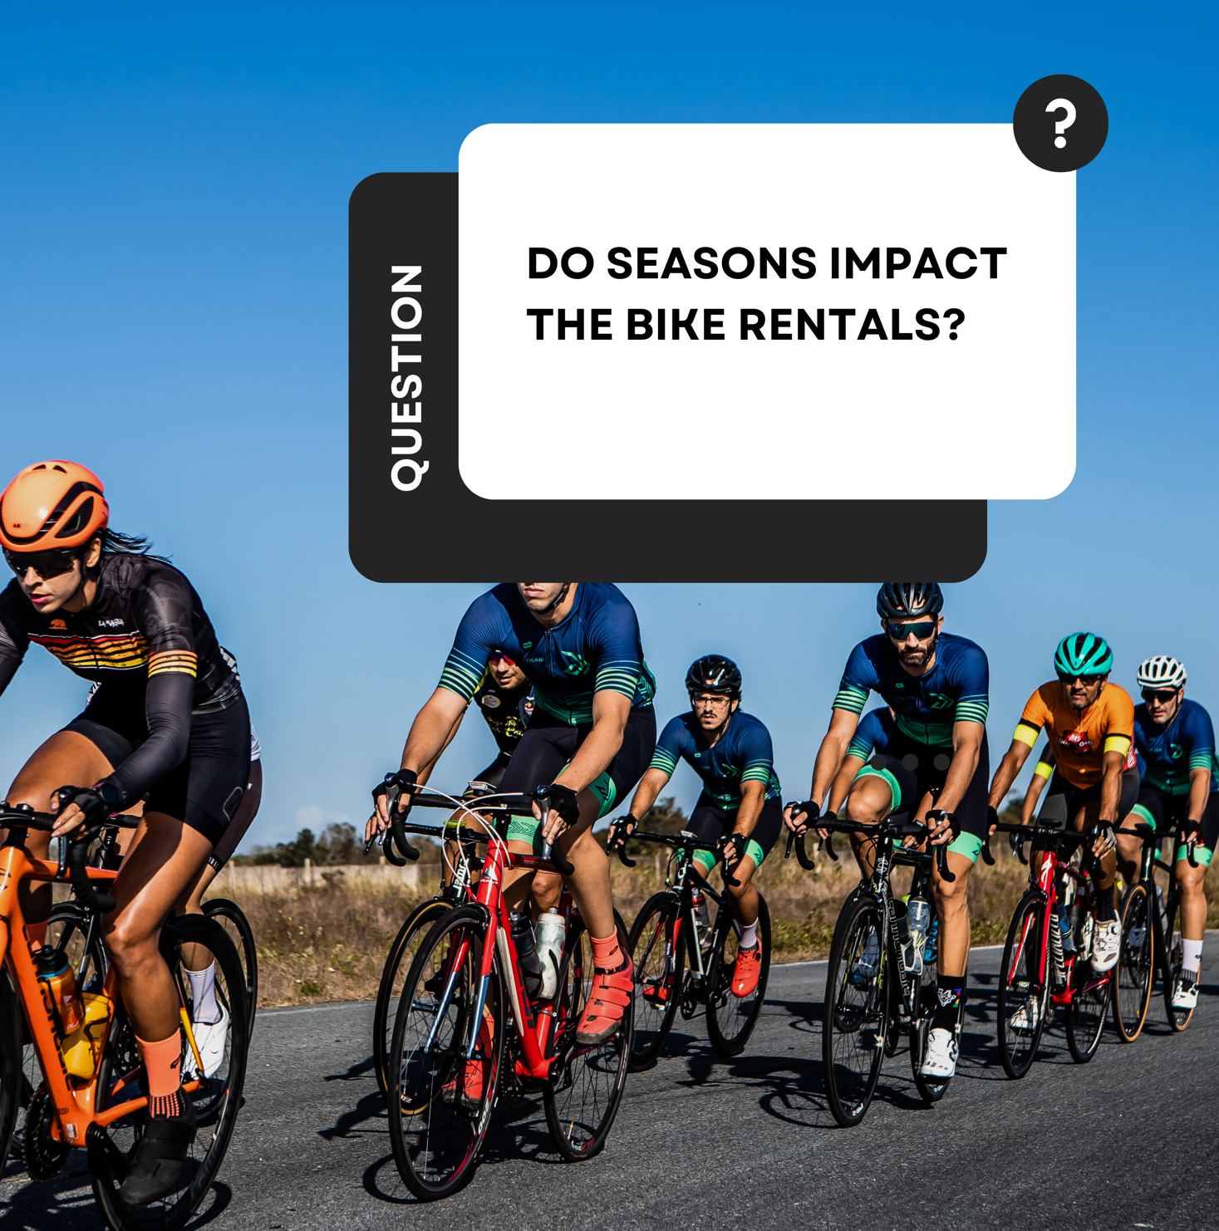

**Interpretation:**

The demand for bike rentals is the lowest in Winter, possibly due to colder temperatures and potentially more adverse weather conditions that make cycling less appealing or safe. Spring shows a significant increase in rentals compared to Winter. This could be due to warmer weather and more favorable conditions for outdoor activities. Summer has the highest demand, likely due to the best weather conditions for cycling, such as warm temperatures and longer daylight hours, encouraging recreational activities and commuting by bike. Fall decreases compared to Summer but still maintains higher demand than Winter. This suggests that while cooler temperatures and changing weather patterns may reduce the inclination to rent bikes, the decrease is less severe than in Winter.

The analysis (Figure. 4) reveals that bike rentals experience substantial fluctuations across different seasons, indicated by a high standard deviation of 217,857.83. The rental numbers vary significantly, ranging from about 471,348 to 1,061,129, showing a pronounced seasonal impact on demand. This significant variance makes it challenging to predict bike rental demand accurately for any specific season without considering other variables. For bike rental companies, this information is crucial for effective planning. Understanding the seasonal patterns—lower demand in winter and higher in summer—can inform inventory management, maintenance scheduling, and marketing strategies. Additionally, this data is valuable for city planners and transportation departments for infrastructure and resource allocation decisions, as it highlights the strong seasonal nature of bike rentals.

**CORRELATION (WEATHER):**

Conducting correlation analysis (Figure. 2) can be beneficial in uncovering significant links between several measures of estimations. After completing a correlation analysis, the following insights were found.

* Season and Total Rentals: The correlation of 0.62883027 suggests a moderately strong positive relationship. This means bike rentals tend to increase from one season to the next (likely from winter to summer).
* Temperature and Total Rentals: The correlation of 0.62749401 is also a moderately strong positive relationship, indicating that higher temperatures are associated with increased bike rentals. This is intuitive as more people will rent bikes in warmer weather.
* Humidity and Total Rentals: The correlation is very low and negative (-0.1006586), suggesting a weak inverse relationship, meaning that higher humidity is slightly associated with lower bike rentals, but the effect is not strong.

The demand for bike rentals positively correlates with favorable weather conditions (higher temperatures). Unfavorable conditions (higher humidity) negatively correlate with rentals, although these relationships are weaker. These insights can be valuable for planning and operations.

**REGRESSION STATISTICS (Figure. 3):**

* Multiple R (0.90567105): This value indicates a very high correlation between the predictors and the response variable (bike rentals), which is good for the predictive strength of the model.
* R Square (0.82024004): The model explains approximately 82% of the variability in bike rentals, which is relatively high, meaning the model fits the data well.
* Adjusted R Square (0.81513144): This modified R Square has been adapted for the number of predictors in the model. It's still high, indicating a good fit.
* Standard Error (812.581162): This is the average distance the observed values fall from the regression line. Considering the context, it is a reasonable amount of error.
* ANOVA (Analysis of Variance): The F-statistic (234.993171) and the Significance F (7.121E-229) suggest that the regression model is statistically significant, meaning the predictors do explain a substantial portion of the variation in bike rentals.
* Coefficients: The coefficient for 'Season (286.167369)' is positive and significant (p < 0.05), which suggests that an increase in the 'Season' variable is associated with an increase in bike rentals. This aligns with the notion that rentals are higher in the summer. To increase sales, focus on marketing efforts during the transition to summer, and optimize bike availability. The Temperature (2430.582736) has a positive and significant coefficient, indicating that as temperature increases, so do bike rentals. Marketing strategies that emphasize outdoor activities during warmer days can increase rentals. Humidity (-960.09241) has negative coefficients, suggesting higher humidity is associated with fewer rentals. Offering weather-related promotions (e.g., discounts on humid days) could mitigate this negative impact.

**STATISTICAL EXPLANATION FOR INCREASING SALES:**

Since the 'Season' variable for Summer has a strong positive influence, we should focus on seasonal peaks like Summer, Spring, etc. Enhancing bike availability and maintenance during high seasons like summer and expanding rental hours will help the company increase sales. Use weather forecasts to offer weather-based promotions. On expected warmer days, promote bike rentals more aggressively. Consider strategies to encourage rentals, such as discounts or special offers for days with high humidity or wind speed. The model can forecast rentals at different locations and tailor strategies accordingly. So, to increase bike rental sales, focus on leveraging favorable weather conditions, optimize the availability of bikes during peak seasons, and employ marketing strategies that target the identified significant predictors. Additionally, develop strategies to counteract the negative impact of less favorable weather conditions.

**MARKETING STRATEGY:**

Weather-based marketing utilizes weather conditions to customize advertising messages to consumers, boosting marketing campaigns' value and performance. (Golden, 2023) The regression study, wherein variables such as temperature and humidity can be utilized to predict the demand for bike rentals. After analyzing and interpreting the winter regression data (Figure. 1), this season demonstrates the lowest rental statistics among the data provided.

**Interpretation:**

However, the impact of temperature and humidity on bike rentals involves coefficients, significance (P value), and confidence intervals. The statistical analysis of bike rental data shows that temperature and humidity significantly influence rental numbers. The positive temperature coefficient (2178.956258) indicates a potential increase in rentals with rising temperatures. However, this relationship is not statistically significant (p-value: 0.120490944), as shown by the wide 95% confidence interval including zero. Conversely, the negative humidity coefficient (-960.4390419) and its significant p-value (0.002327952) demonstrate decreased bike rentals with higher humidity levels. The 95% confidence interval for humidity does not include zero, confirming its considerable negative impact. While temperature's effect on rentals is uncertain, humidity is a reliable predictor. Operational strategies could focus on mitigating the adverse effects of high humidity on bike rentals.

**WEATHER-BASED MARKETING CAMPAIGN:**

“Cycle Through the Seasons: Bike Rental Marketing Campaign"

This campaign helps the company increase bike rentals by targeting potential customers with ads triggered by optimal temperature and humidity conditions.

**Weather Triggers & Seasonal Adjustments:**

Set a threshold temperature range that historically leads to increased bike rentals. Determine a maximum humidity level for the trigger, as high humidity deters outdoor activity. Adjust the temperature triggers according to the season. For instance, lower temperatures might be more comfortable for cycling in spring and fall compared to the summer. Using historical sales data to refine these temperature ranges for each season, ensuring the triggers are based on times when people are most likely to rent bikes.

**Creative Messaging & Real-Time Activation:**

Develop dynamic ads that automatically update to feature current local weather conditions alongside the ideal conditions for bike riding. Use a programmatic DOOH platform with weather targeting capabilities to display ads when and where the weather conditions meet set triggers. Ensure that the ads are displayed on DOOH screens in high-traffic areas and near bike rental locations for maximum visibility. (Golden, 2023) While DOOH will be the primary channel, complement it with social media ads and mobile alerts to reach consumers on the go. Synchronize messages across all platforms for a cohesive campaign.

**Performance Tracking:**

Monitor the performance of the weather-based ads in real-time, analyzing the rental data against weather conditions. This data could be used to optimize the campaign's effectiveness continuously. By implementing this strategy, a responsive and dynamic marketing campaign can be created that aligns perfectly with consumers' willingness to rent bikes under favorable weather conditions, thus potentially increasing the bike rental rates.

**REFERENCES:**

Minerva, F., &amp; Giubilini, A. (2023, May 31). Is AI the future of Mental Healthcare? Topoi :

An international review of philosophy. <https://www.ncbi.nlm.nih.gov/pmc/articles/PMC10230127/>

Bahr, L. (2023, April 16). “super mario bros.” is officially the biggest movie of 2023: $678

million worldwide. USA Today. <https://www.usatoday.com/story/entertainment/movies/2023/04/16/super-mario-bros-biggest-movie-2023-box-office/11677953002/>

Henson, B. (2023, November 9). Can we still avoid 1.5 degrees C of global warming? " Yale

climate connections. Yale Climate Connections. <https://yaleclimateconnections.org/2023/11/can-we-still-avoid-1-5-degrees-c-of-global-warming/#:~:text=With%20a%20strong%20El%20Ni%C3%B1o,warmer%20than%20the%20preindustrial%20benchmark>.

Golden, A. (2023, July 18). How to add weather-based marketing in your brand’s forecast.

Digital Out of Home Advertising (DOOH). <https://www.vistarmedia.com/blog/why-weather-based-campaigns-for-brands#:~:text=How%20does%20weather%2Dbased%20marketing,conditions%20in%20their%20local%20area>.

**APPENDIX:**

**Figure. 1**

**Figure. 2**

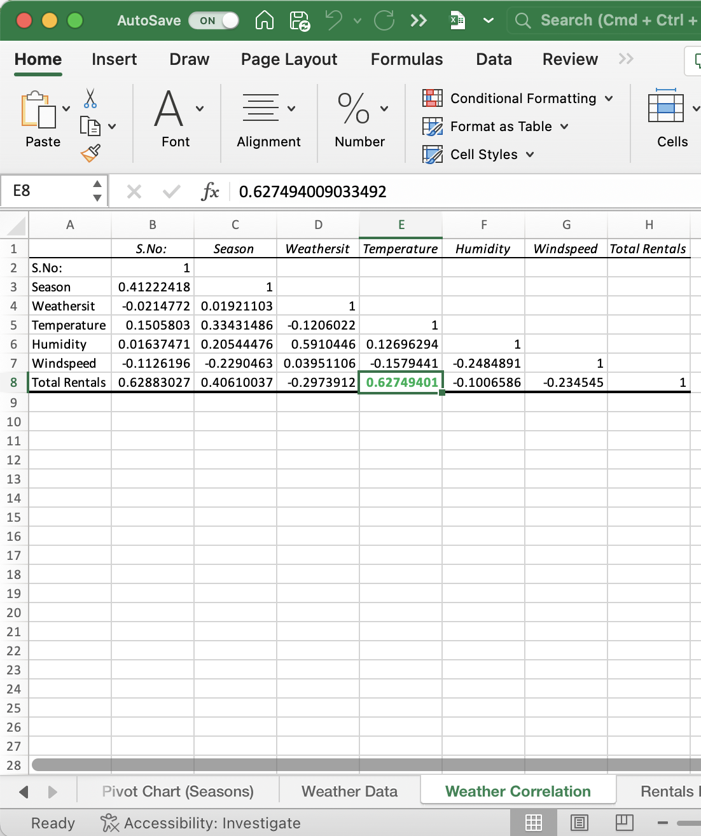

**Figure. 3**

